|  |  |
| --- | --- |
| **WC Logo.emf** | **Staff Report to the Weber County Commission**  *Weber County Planning Division* |
|  | |

****Synopsis****

****Application Information****

**Application Request:** A public hearing to consider and take action on a request to vacate the 10-foot public utility easement, located along the north side of lot 2 of the Lake View Estates, 1282 N 7100 E, Eden.

**Agenda Date: Wednesday, November 30, 2021**

**Applicant:** Gerald Allred

**File Number:** UVL110121

****Property Information****

**Approximate Address:** 1350 N 7100 E, Eden

**Project Area:** 7.8 acres

**Zoning:** AV-3

**Existing Land Use:** Residential

**Proposed Land Use:** Residential

**Parcel ID:** 21-103-0004, 21-103-0003, 21-103-0002

**Township, Range, Section:** T6N, R2E, Section 06

****Adjacent Land Use****

**North:** Residential **South:** Residential

**East:** Residential **West:** Residential

****Staff Information****

**Report Presenter: Felix Lleverino**

[flleverino@co.weber.ut.us](mailto:flleverino@co.weber.ut.us)

**801-399-8767**

**Report Reviewer: SB**

Applicable Ordinances

* Title 101, Chapter 1, General Provisions, Section 7, Definitions
* Title 104, Chapter 2, Agricultural Zones
* Title 104, Zones, Chapter 28, Ogden Valley Sensitive Lands Overlay Districts
* Title 106, Subdivisions, Chapter 1-8 as applicable

Development History

This Subdivision was originally recorded in 2004 as Lake View Estates, a two-lot subdivision.

On November 1, 2021, Mr. Gerald Allred submitted an application for approval of an amended plat.

Background and Summary

This is a proposal to amend Lake View Estates, by moving a shared boundary line between lots one and two. The original dedication plat recorded in 2004 created a 10’ public utility easement along the shared boundary line. This amended plat includes a request to vacate the ten-foot public utility easement through the legislative vacation process.

Written notification to Rocky Mountain Power, Dominion Energy, and Mountain Canal Irrigation Association have been sent.

The proposed subdivision amendment and lot configuration are in conformance with the current zoning as well as the applicable subdivision requirements as required in the Land use Code of Weber County Utah.

State code (17-27a-609.5), (17-27a-605) governing the process to vacate a public utility easement is being followed.

Summary of County Commission Considerations

The County Commission will need to determine if there will be any detrimental impacts caused by vacating the proposed public utility easements. Utah Code §17-27a-609.5 (4) *“The legislative body may adopt an ordinance granting a petition to vacate some or all of a public street or county utility easement if the legislative body finds that:”*

1. *good cause exists for the vacation; and*
2. *the public interest or any person will not be materially injured by the proposed vacation.*

Utah Code §17-27a-609.5 (5) states that *“The legislative body shall ensure that one or both of the following is recorded in the office of the recorder of the county in which the land is located:*

1. *A plat reflecting the vacation; or*
2. *An ordinance described in subsection (4); and*
3. *A legal description of the public street to be vacated.*

Analysis

*General Plan:* The proposal conforms to the Ogden Valley General Plan by maintaining the existing density provided by the current zoning and existing approvals (2016 Ogden Valley General Plan, Land Use Principle 1.1).

*Zoning:* The subject property is located in the Agricultural Valley (AV-3) Zone. The purpose and intent of the Agricultural Valley zone is identified in the LUC §104-12-1 as:

*The AV-3 Zone and A-1 Zone are both an agricultural zone and a low-density rural residential zone. The purpose of the AV-3 Zone and A-1 Zone is to:*

1. *Designate low-intensity farm areas, which are anticipated to develop in a rural residential development pattern;*
2. *Set up guidelines to continue agricultural pursuits, including the keeping of farm animals; and*
3. *Direct orderly low-density residential development in a continuing rural environment.*

The minimum lot size in the AV-3 zone is three acres and the minimum lot width is 150 feet. Both lots within this development comply with the zoning site development standards.

*Mandatory Services*: Lot one and two of Lake View Estates are approved for the placement of a septic system. Culinary water is available from an operational private well. Secondary water is available from Mountain Canal Irrigation Association.

*Sensitive Lands:* This subdivision is located within zone three of the public water source protection overlay. The use of single-family dwellings is permitted within the overlay zone. Zone three does not restrict the use of septic systems for single-family dwelling lots. The subdivision is not located in a floodplain or a geologic hazards area.

*Review Agencies:* The final subdivision plat is under review by the County Surveyor and County Engineer. Review comments from these agencies are anticipated to be minimal, as this is only a lot line adjustment. All review comments from review agencies will need to be addressed before the subdivision plat can record.

Staff Recommendation

Staff recommends approval of a request to vacate 10-foot public utility easements, located along the north side of lot 2 of the Lake View Estates, 1282 N 7100 E, Eden. Approval from the County Commission is subject to the following conditions:

1. The Amended plat will depict the area to be vacated.
2. All county review agencies shall approve of the vacation and the subdivision plat amendment.
3. All utility providers shall provide written approval or objection on or before the date of the public hearing. If no approval or objection is received, the county may record the amended plat.

The recommendation is based on the following findings:

1. Vacating the proposed public utility easement will not have a negative effect on the Ogden Valley General Plan.
2. Based on the proposed subdivision amendment, good cause exists to vacate the easement.
3. The public interest or any person will not be materially injured by the proposed vacation.
4. This subdivision proposal conforms to all applicable subdivision and zoning requirements.

Exhibits

1. Proposed amended plat
2. Plat showing easement vacation

Location Map 1

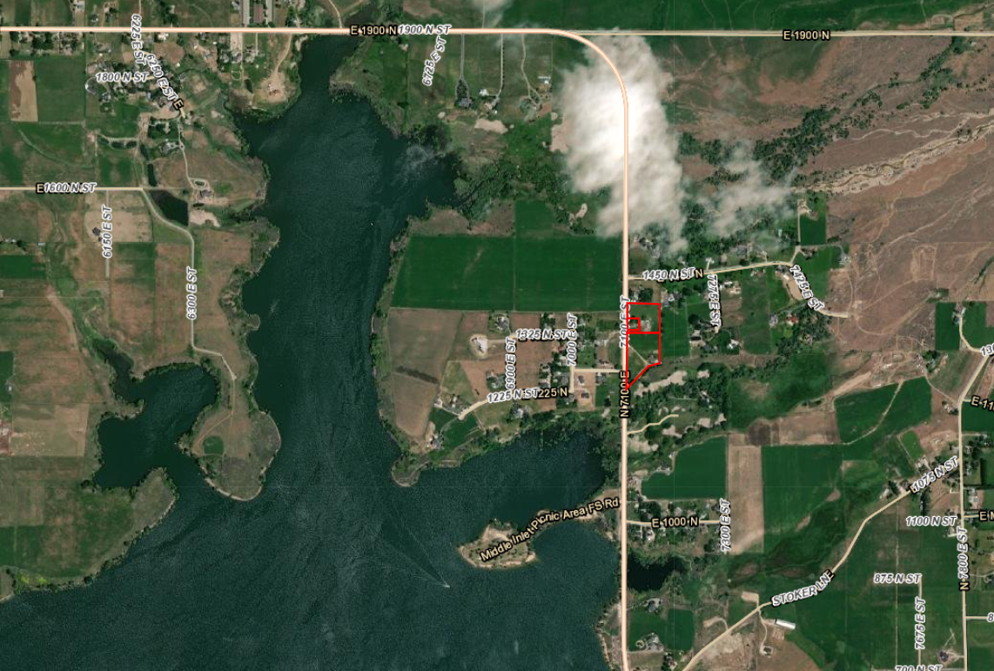

Exhibit A

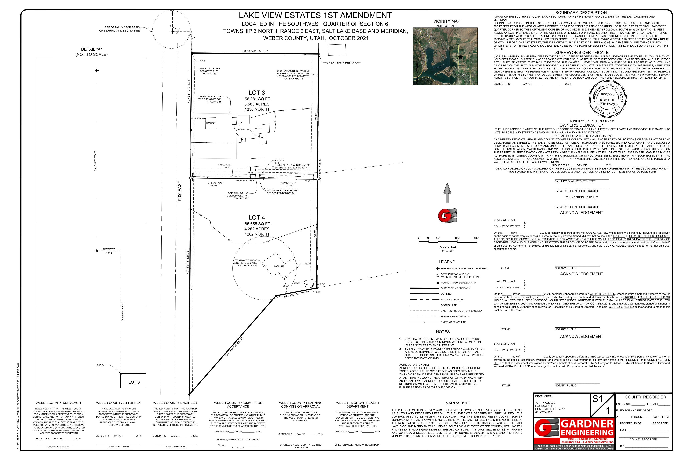

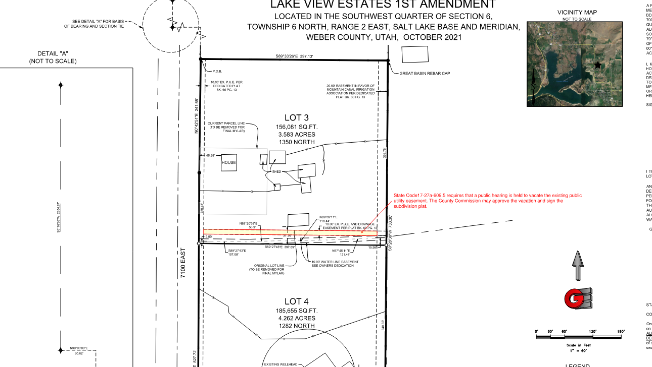Exhibit B